ShopNest PowerBI Capstone Project  
Dashboard Report

**Student Name – Chavi Madan**

**Question 1: Identify the rating distribution in the Shop_Nest dataset, showcasing ratings categorized as Excellent, Very Good, Good, Bad, and Very Bad, along with corresponding orders.**

**Visualization:**

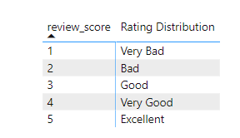

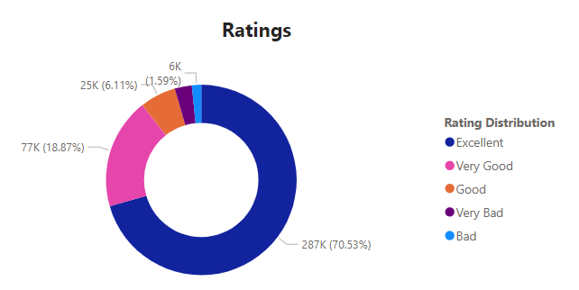

**Key Insights and Findings:**

The above visualization depicts the rating distribution based on different review score received from customers. The central donut chart showcases the count of orders categorized by rating distribution.

The rating analysis reveals a diverse distribution among orders, with approximately 70% orders earning **Excellent** rating, signifying exceptional customer satisfaction. Meanwhile, around 19% orders are attributed to **Very Good** rating, indicating generally positive feedback with potential areas for improvement. In contrast, 2% orders received the lowest rating as **Very Bad**, highlighting areas requiring immediate attention.

**Question 2: What are the top 10 and bottom 18 most popular product categories in the ShopNest dataset? Please list them based on the number of orders.**

**Visualization:**

**Key Insights and Findings:**

The above visualization provides a comprehensive view of both high-performing and low-performing product categories based on number of orders received. The highest-ranked product category is **Bed & Bath Table** with approximately 9k orders followed closely by Health Beauty and Sports Leisure. The bottom 18 product categories have significantly lower order volumes, indicating weak demand. The lowest-ranked product category is **Security and Services**.

**Question 3: List the total number of active sellers by yearly and monthly.**

**Visualization:**

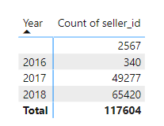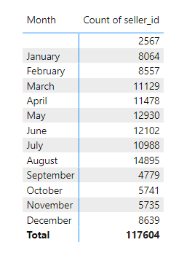

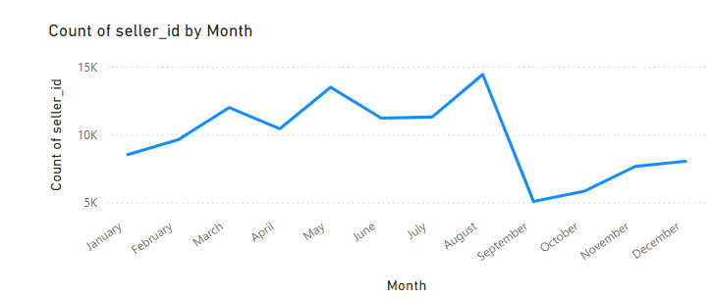

**Key Insights and Findings:**

This segment of the dashboard presents a line chart detailing the total number of active sellers year-wise and month-wise.

The analysis revealed that year-wise in **2018**, there were **highest** active sellers for the products and in **2016**, the count of active sellers was **lowest**. Also, if we see month-wise, in the month of **August**, the active seller count was **highest**, and **September** month shows the **lowest** count of active sellers.

**Question 4: Which payment methods are most commonly used by ShopNest customers.**

**Visualization:**

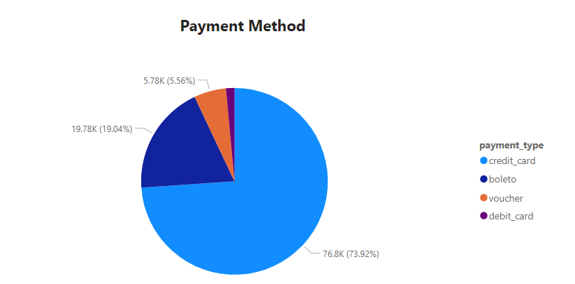

**Key Insights and Findings:**

This section of the dashboard presents a pie chart describing various payment methods used by customers, showing **Credit Car**d payment method has dominated against all other payment methods.

The predominant payment method is **credit card**, totalling **77,000 transactions**, followed by **Boleto** with approximately **20,000 transactions**, **voucher** with **6,000 transactions**, and **debit card** with around **1500 transactions**. Credit cards often offer convenience, rewards, and buyer protection, contributing to their popularity. Debit card usage might lag due to fewer incentives or perceived security issues as compared to credit cards.

**Question 5: Identify the product category wise profit margin.**

**Visualization:**

**Key Insights and Findings:**

The above line chart depicts profit margin across various product categories, offering a dynamic overview of performance. **Home Comfort, Christmas Supplies and Flowers** exhibit profit margins of over 92%, 72.5% and 74% respectively, making them highly profitable segments.

These high-margin categories offer opportunities to enhance profitability further by promoting them more aggressively or expanding product offerings in these segments. Several product categories show lower profit margins and may require a deeper review of cost structures.

**Question 6: Determine the monthly payments made by customers using credit cards.**

**Visualization:**

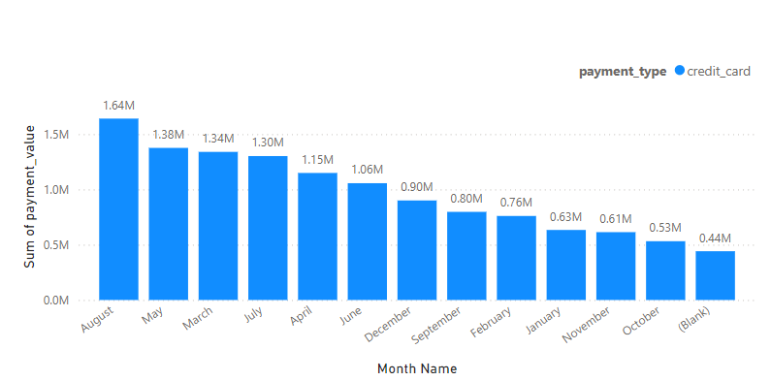

**Key Insights and Findings:**

The above analysis reveals a steady increase in the total monthly payments made by customers using credit cards. This could indicate a growing customer preference for credit card transactions.

Certain months show consistent levels of credit card payments, reflecting stable purchasing behaviour among customers. **October and November** month show lowest credit card usage while **August** month show significantly high usage of credit card by the customers.

**Question 7: Identify sellers categorized by city, excluding cities starting with the letters S and B.**

**Visualization:**

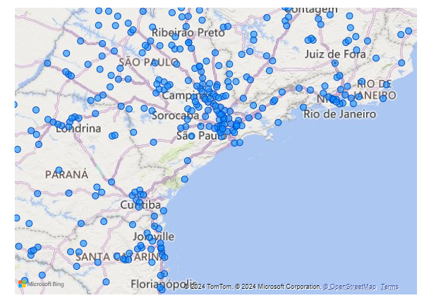

**Key Insights and Findings:**

The map illustrates city-wise available sellers excluding cities starting with the letters S and B. **Curitiba** city has the highest number of sellers (count 127) followed by **Rio de Janeiro** city (count 96) and **Ribeirao Preto** city (count 56). The presence of more sellers in these cities suggests stronger market competition and higher potential sales volumes.

On the other hand, cities with low seller representation, shows untapped market potential for sellers and providing a chance for business expansion.

**Question 8: Create a dynamic visual that compares the number of delayed orders to the number of orders received earlier for each month. Utilize the drill through the cross-report feature to provide a detailed analysis of late and on-time deliveries.**

**Visualization:**

**Key Insights and Findings:**

The dashboard offers a holistic view of timely and delayed orders across months. The column chart displays monthly trends and delayed orders with bars.

**March** month experiences high customer spending, driving both timely and delayed orders. Conversely, **September** month witnessed reduced activity post-summer holidays. It's essential to investigate factors to address the root causes of these delays and enhance customer satisfaction.

